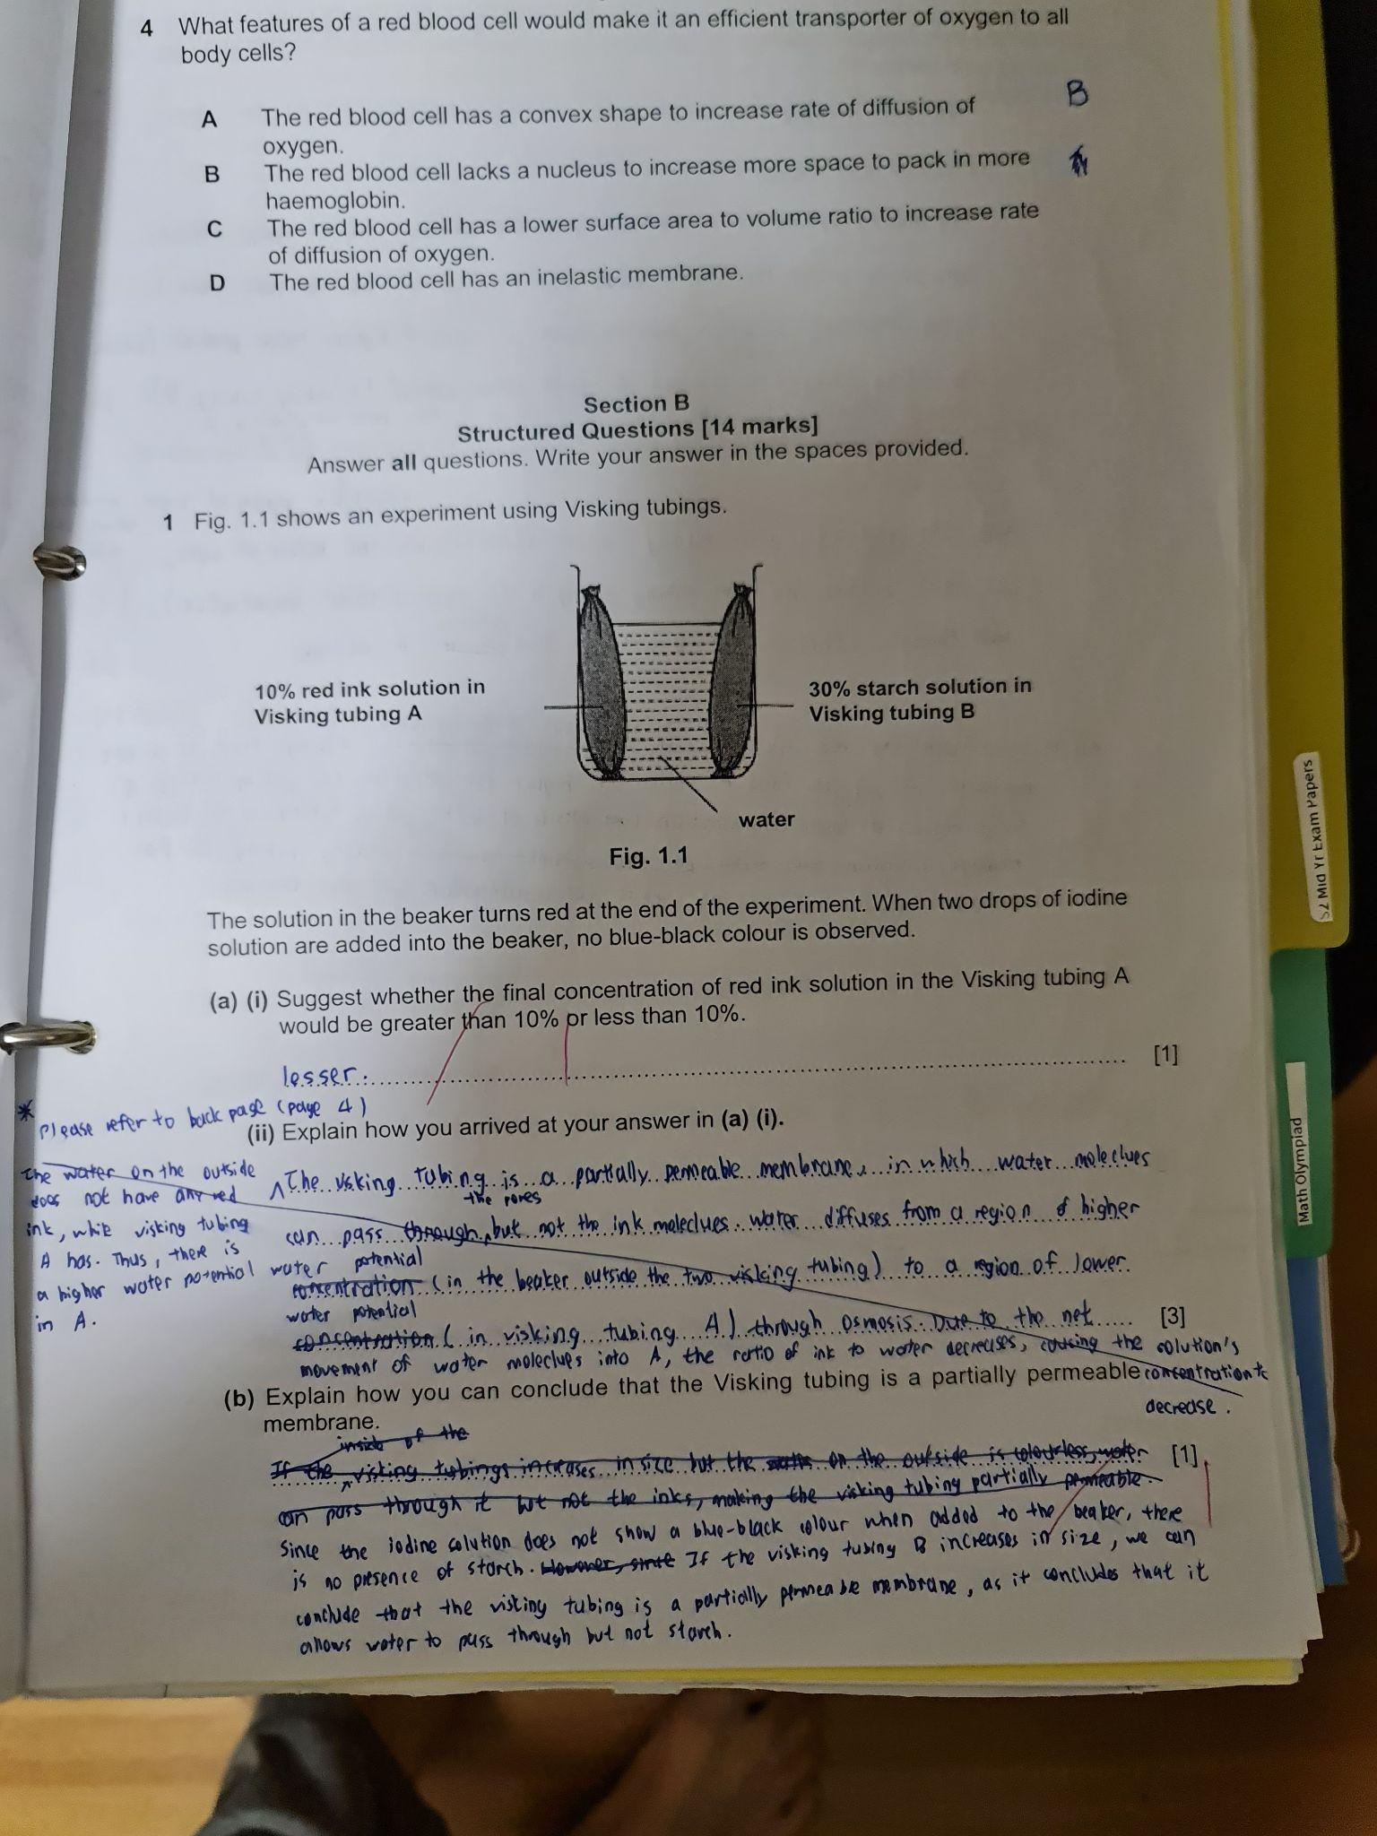

1. (i) Suggest whether the final concentration of red ink solution in the Visking tubing A would be greater than 10% of less than 10% [1]

(ii) Explain how you arrived at your answer in **(a) (i)**. [3]

1. Explain how you can conclude that the Visking tubing is a partially permeable membrane [1]

(c) (i) What would happen to the mass of the Visking tubing B at the end of the

Experiment? [1]

(ii) Explain your answer to **(c) (i).** [3]

(d) Would you expect the contents of the Visking tubing B to turn red at the end of the

experiment? Explain your answer. [2]